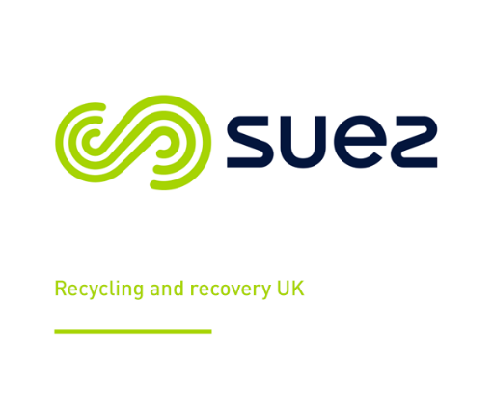

Team Leader Driver / Loader Evening Shift

Contract type Full time

Working Pattern Full time

Location based Kensington & Chelsea

Hours per week 37.5 hours, working Monday to Friday, 14.00pm to 22.00pm
Overtime is available but not guarantee.
Salary £31,660.81 per year, plus £182.00 per month

Are you an experienced Driver, with a current class B licence

What will I be doing?
- Monitor collection crews and carrying out inspections accordingly.
- Monitor fleet compliance and ensuring health and safety is always kept to a high standard.
- You will also be tasked with various day to day roles which will include timesheets, ensuring staff levels are kept in line with budget, ensuring all staff are briefed on the roles and responsibilities required of them, issue toolbox talks (huddle cards), safe working procedures, SIM observations etc. as and when required and carry out inductions.
- Providing excellent customer service and dealing with complaints.
- You will also be responsible for ensuring activities of all employees comply with SUEZ’s policies and procedures and relevant health and safety legislation.

What are the requirements?
- You must be able to demonstrate a passion for professional driving coupled with good communication skills and a willingness to be part of a successful hardworking team, delivering a high level of customer service.

- Have a Class B licence.

- Experience of working on the street cleansing operation within K&C

Who we are.
At SUEZ the efficient and sustainable management of resources around the globe is at the heart of everything we do. Respect – acting ethically and with integrity – is one of our core values. We’re passionate about the environment and believe in protecting our world. Over 90,000 likeminded people worldwide makes for an incredible team, where collaboration and trust are part of the way we work. With true team spirit, we can give our customers a standard of service that goes above and beyond and ensure that our local communities have access to essential water and waste services.
We thank our people for all they do with development opportunities, wide-ranging benefits and rewards that reflect their hard work. In a friendly, supportive environment, you’ll be inspired to grow and play your part in creating a better future for all.

*No agencies please*

Closing Date TBC

Once we have sufficient applicants, we withhold the right to close job vacancies early.

Please contact Abderrahmane Kherbache, abderrahmane.kherbache@suez.com

